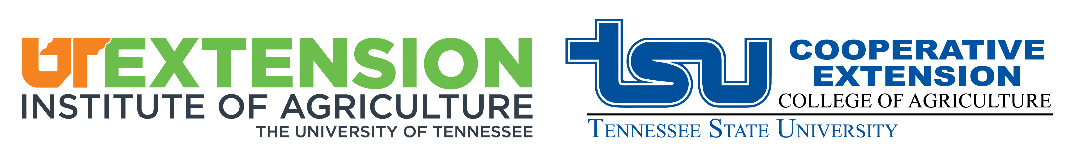
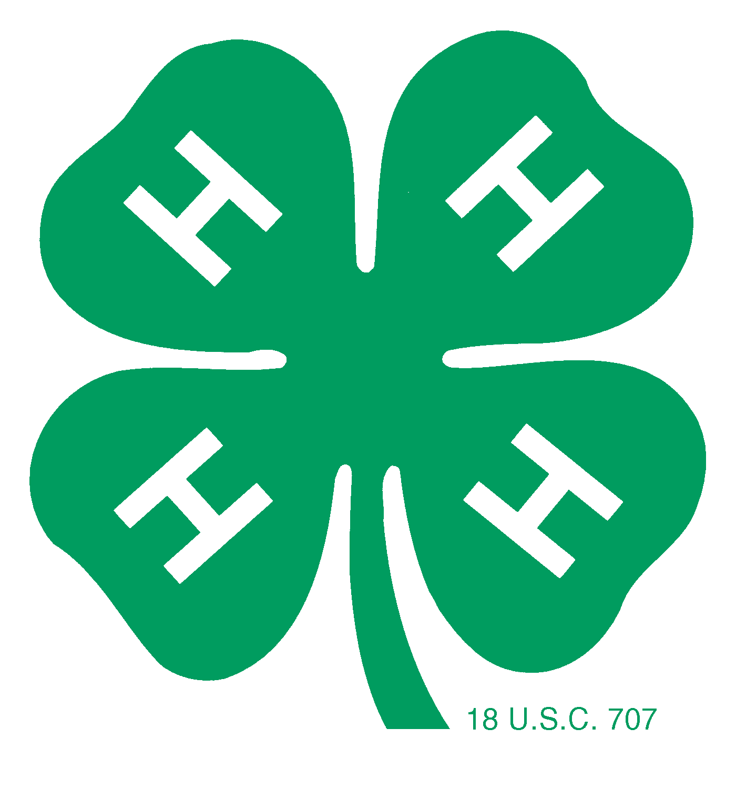

4-H Poster Art Contest
2025 - 2026

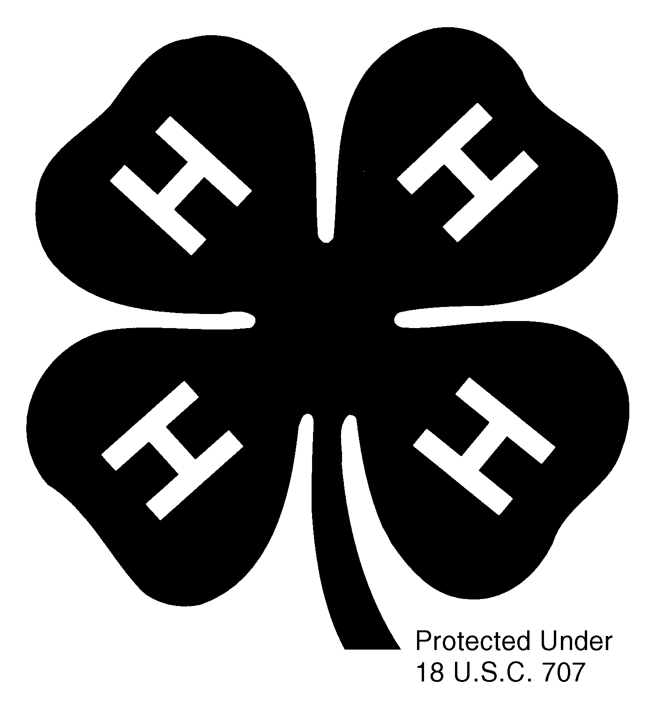
Put on your creativity hats and get ready for the Poster Art Contest! All students are encouraged to participate in this opportunity to draw your way to the top! Each individual participating will receive a 4-H ribbon. Classroom winners will advance to the county, where one overall winner will be awarded a trophy and top honors.

Here are the guidelines:
For the local 4-H Classroom contest we want students to make their poster on standard 11 by 8.5 paper. A committee will select the top ten from the county and those members will have to reproduce on ½ sheet poster board for the Regional Competition.

- Posters must be horizontal (11 by 8.5).
- Posters must have the 4-H clover or say 4-H on it somewhere.
- No objects can extend 1/8 inch from the surface.
- Copyright characters cannot be used.
- The message should be clear and simple.
- Design can be hand drawn, stenciled, blocked or computer generated.
- Members name, address, age, grade, school, and teachers name must be on back of poster.

All students will receive a participation ribbon. First & second place classroom winners’ poster will advance to county competition, they will also receive a first or second place ribbon. Posters may be sent via interschool mail. All posters must be in the Extension Office by December 8,2026. Please, if you have any questions contact the UT Extension Washington County at 753-1680 or email lgarland@utk.edu, bnuckols@utk.edu, sballance@utk.edu, or mphipps@utk.edu

